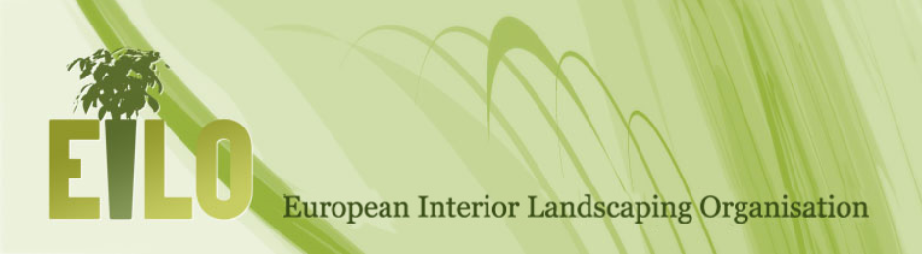

Third international EILO conference Program

Thursday, December 3rd 2015

Friday, December 4th 2015 (optional)

At Paysalia, Lyon, France

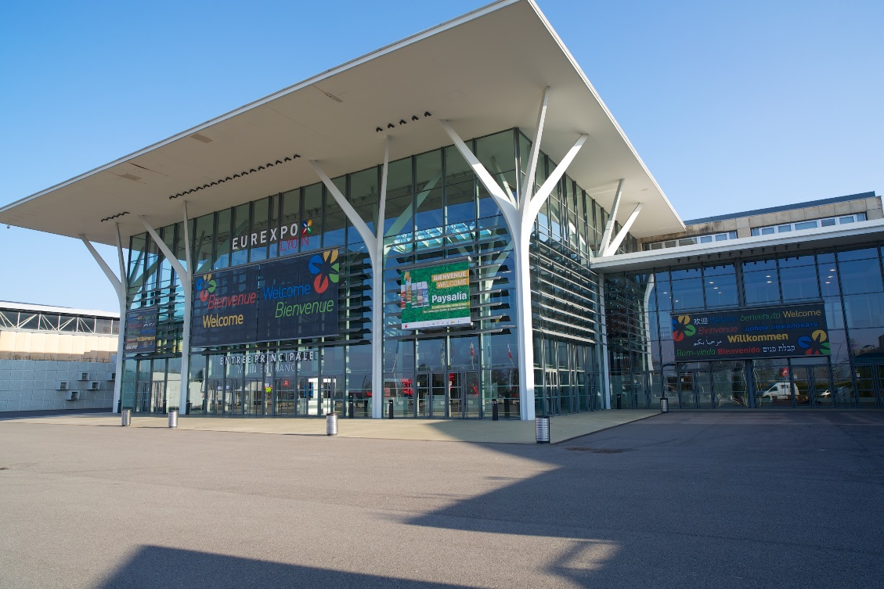

Conferences- dedicated to EILO members, and translated in French, English and German
All conferences are on first floor, mezzanine 3 and 4

Room Mezzanine 4:
8.00 am: Welcome coffee

Room Mezzanine 3:
9.00 am: Opening by Robert Van Aerts, EILO
9.15 am: Speech by Catherine Muller, President of Paysalia and President of Unep
9.30 am: Conferences translated in French, English and German with:
- Mrs. Kohlrausch and Dr Bucher, Hochschule Weihenstephan-Triesdorf(30min)
Increasing the humidity by Vertical greening - is that possible?

- Mr Stolze, Fraunhofer Institut (30 min)
Vision of green building from a research center

- Dennis Hauer, Urban Climate Architect (30 min)

How to make Green indispensable for an architect?

Over the last years there is a lot of attention and interest for building with green. But in practice it is difficult to get green in buildings realized. Dennis Hauer will tell about his experience to make green 'indispensable' for an architect.

About Dennis Hauer, circular architect:
Our generation stands at the start of a new era. We have to move towards a circular economy to face the challenges we have formed over the last 100 years. To give an answer to the rise of earth’s temperature and CO2 levels, the lost of biodiversity and the exhaustion of virgin materials we have to act now!
Architecture can't solve these problems, but Dennis is convinced that architects can play a role in giving design answers and use their keyrole in the design process to bind parties and come to multidisciplinairy solutions.
Dennis is senior architect at Urban Climate Architects which is located in Delft and Groningen in the Netherlands.
His work is characterized by a high level of sustainability in general and a healthy living environments in particular. From his specialized knowledge and fascination for planting in the urban landscape Dennis is a frontrunner on innovative use of greenery to create a vital living and working environment.
http://ucarchitects.com/

- Patrick Blanc, Botanist, green wall pioneer (1 h)
Vertical Garden: from nature to the city

Patrick Blanc is a biologist, botanist and a researcher at the French National Center for Scientific Research specialized in undergrowth plants. He invented the concept of vertical green walls. He created 250 green walls on all continents and is famous all over the world.

Vertical gardens seem familiar, decades after Patrick Blanc invented the concept. Thanks to his knowledge about the secrets of the plants, he invites nature to flourish on the walls of all kinds of monuments and buildings. But how did he make his vision and creations evolve over time

12.30 am: Closure by Robert Van Aerts and Emmanuel Mony, President of ELCA

Interior Landscaping Village:

12.40 am: French lunch

FORUM Room:
2.30 pm: Conference in french: Thierry Huau, Landscaper and urbanist
NB: this conference is opened to all and only available in French
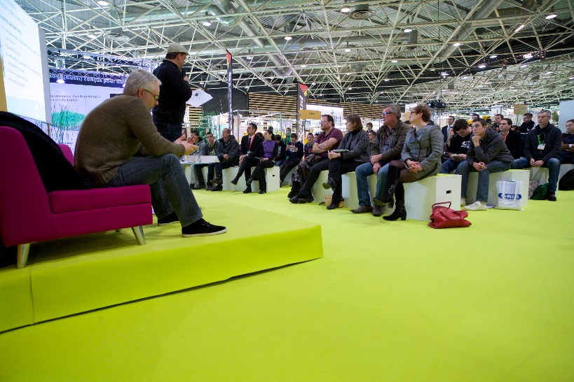

Award Area:
4.00 pm: prize-giving for the competition of the most beautiful project in Interior Landscaping

Evening
5.00 pm: Guided tour of Lyon by bus
7.00 pm: Presentation of Egbert Roozen, VHG/EILO
European lobby, state of affairs in Europe and the role that Eilo can play in Brussels
7.30 pm: Diner in french restaurant

Price (Entrance of Paysalia and EILO conference): 240€ excl tax.
Including Food and drinks but NOT INCLUDING ACCOMODATION

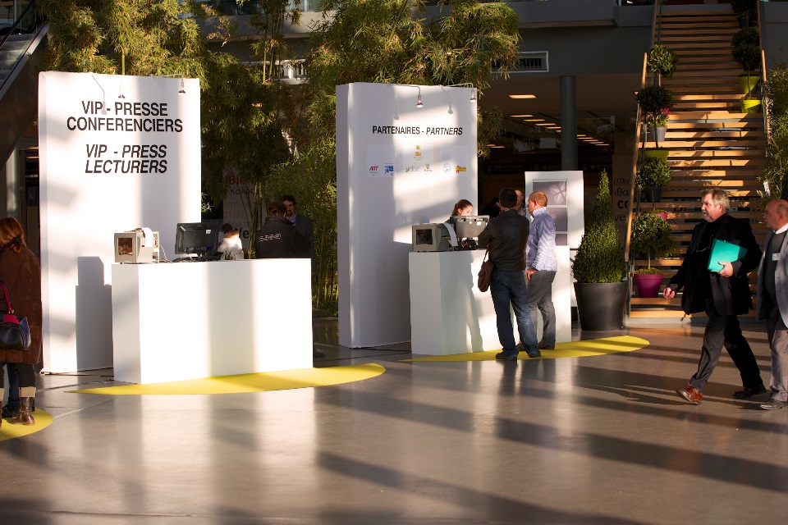

IN OPTION – WITH ADDITIONAL COST
On Friday, December 4th in the morning
9.00 am to 12.00 am: guided tour (French/English) of various remarkable projects in interior landscaping through Lyon and lunch, including the famous district of Confluence
12.00 am: lunch in the restaurant La Sucrière, located in a famous picturesque spot of Lyon

Total Price including Friday morning: 360€ excl tax.
Including Food and drinks but NOT INCLUDING ACCOMODATION
Possibility to visit at a reduced rate the Lyon Biennial of contemporary art in the afternoon

PRACTICAL INFORMATION

REGISTRATION
- Get your badge on www.paysalia.com for free with the code AEL (this badge is required)
- Register on www.eilo.eu/ and pay your fee
- Check all information about accommodation, timetable of Paysalia, restaurants…
The first week of December is a busy period in the city of Lyon, please note that all booking should be done as soon as possible.
ACCESS
Log on to the Visitor Account via the Paysalia website for more details.

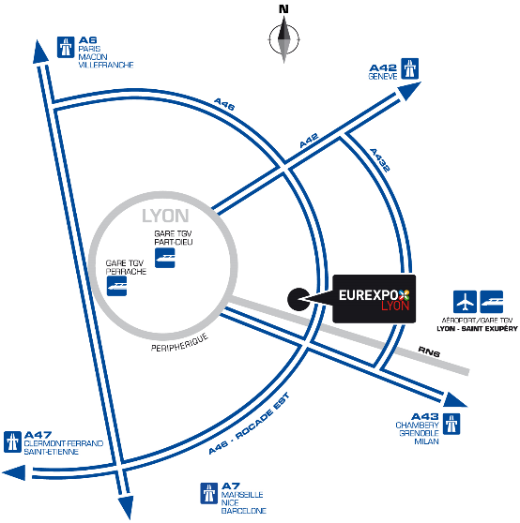
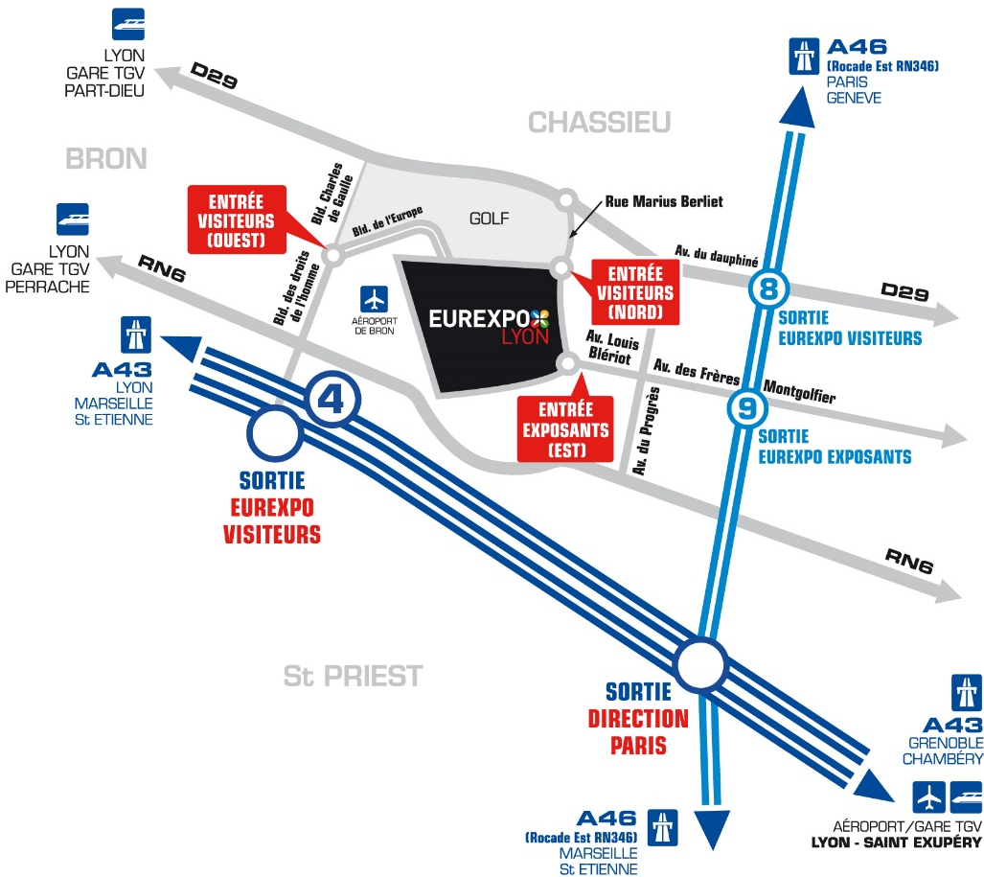

MAP OF PAYSALIA 2015
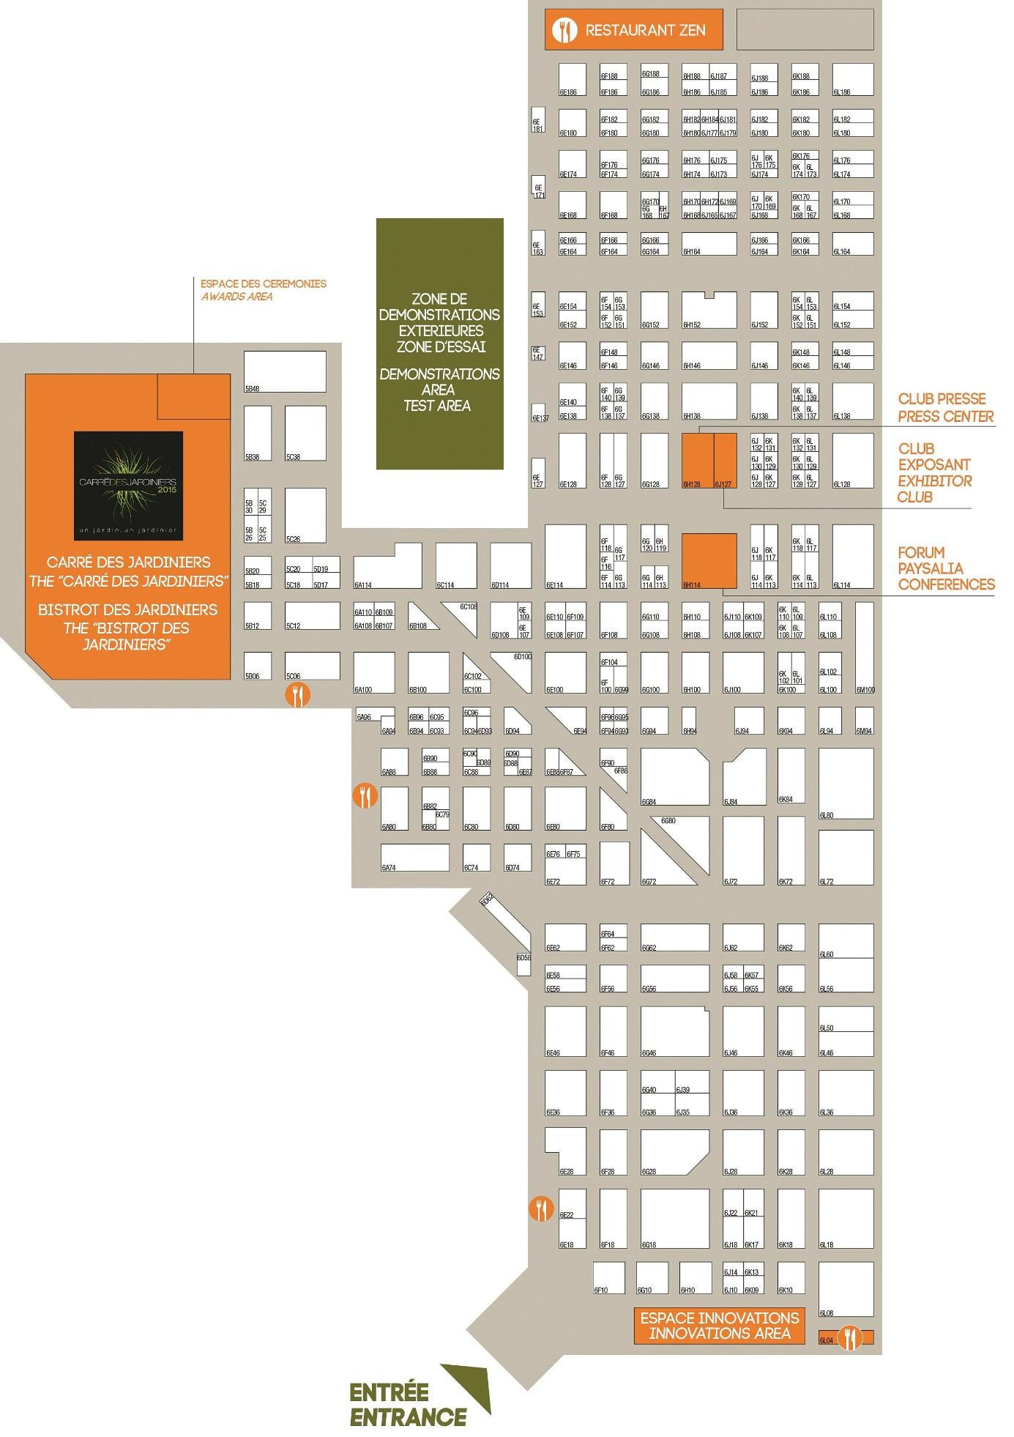
Access to first floor
EILO conferences
Interior Landscaping Village
Award Area

First floor
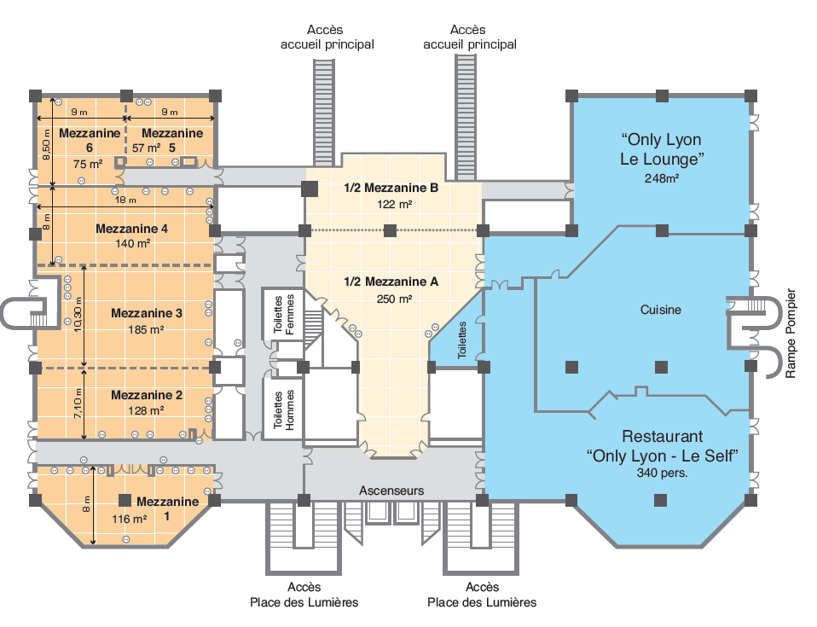
Main entrance

